CCNA Lab Manual
Part 2 - Changing a Static LAN to VLAN 10 and VLAN 20
Using Router-on-a-Stick to Demonstrate Router Subinterfaces
Student: ____________________ | Date: ____________________ | Lab Time: __________

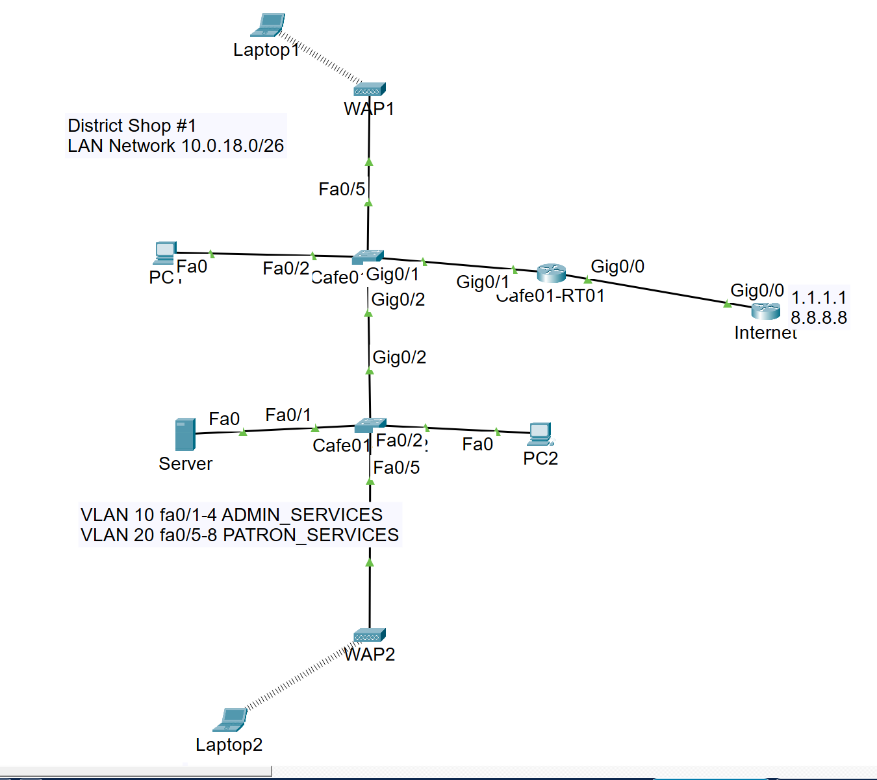
Figure 1. Corrected router-on-a-stick topology: Cafe01-SW01 Gi0/1 to Cafe01-RT01 Gi0/1 and Cafe01-SW01 Gi0/2 to Cafe01-SW02 Gi0/2

Lab Overview
Purpose. Begin with the previously verified static IPv4 network, then divide the switched LAN into VLAN 10 ADMIN_SERVICES and VLAN 20 PATRON_SERVICES. Use one physical link between Cafe01-SW01 and Cafe01-RT01 as an 802.1Q trunk. Configure Gi0/1.10 and Gi0/1.20 on Cafe01-RT01 so students can observe how router subinterfaces provide a separate Layer 3 gateway for each VLAN.
Starting condition: The static baseline must already work. Before changing the VLAN design, PC1 should be able to ping 10.0.18.1, 216.0.5.1, and 8.8.8.8.

Learning Objectives
- Explain why each VLAN requires its own IPv4 subnet and default gateway.
- Create and name VLAN 10 ADMIN_SERVICES and VLAN 20 PATRON_SERVICES on both switches.
- Assign Fa0/1-Fa0/4 to VLAN 10 and Fa0/5-Fa0/8 to VLAN 20.
- Configure Cafe01-SW01 Gi0/1 as the router-facing trunk and Gi0/2 on both switches as the inter-switch trunk.
- Convert Cafe01-RT01 Gi0/1 from a single Layer 3 interface into router-on-a-stick subinterfaces.
- Verify VLAN membership, trunk operation, inter-VLAN routing, and Internet reachability.

VLAN and Addressing Plan
VLAN | Name | IPv4 Network | Gateway | Access Ports
10 | ADMIN_SERVICES | 10.0.18.0/26 | 10.0.18.1 | Fa0/1-Fa0/4
20 | PATRON_SERVICES | 10.0.18.64/26 | 10.0.18.65 | Fa0/5-Fa0/8
Subnet reminder: For VLAN 10, 10.0.18.63 is the broadcast address. For VLAN 20, 10.0.18.64 is the network address and 10.0.18.65 is the first usable host address.

Post-Conversion Static Addressing
Device | Switch / Port | VLAN | IPv4 Address | Mask | Gateway
Cafe01-RT01 | Gi0/1.10 | 10 | 10.0.18.1 | 255.255.255.192 | -
Cafe01-RT01 | Gi0/1.20 | 20 | 10.0.18.65 | 255.255.255.192 | -
Server | SW02 Fa0/1 | 10 | 10.0.18.6 | 255.255.255.192 | 10.0.18.1
PC1 | SW01 Fa0/2 | 10 | 10.0.18.21 | 255.255.255.192 | 10.0.18.1
PC2 | SW02 Fa0/2 | 10 | 10.0.18.22 | 255.255.255.192 | 10.0.18.1
WAP1 | SW01 Fa0/5 | 20 | 10.0.18.66 | 255.255.255.192 | 10.0.18.65
WAP2 | SW02 Fa0/5 | 20 | 10.0.18.67 | 255.255.255.192 | 10.0.18.65
Laptop1 | Wireless via WAP1 | 20 | 10.0.18.84 | 255.255.255.192 | 10.0.18.65
Laptop2 | Wireless via WAP2 | 20 | 10.0.18.85 | 255.255.255.192 | 10.0.18.65
Cafe01-RT01 | Gi0/0 | WAN | 216.0.5.2 | 255.255.255.252 | -
Internet | Gi0/0 | WAN | 216.0.5.1 | 255.255.255.252 | -

Router-on-a-Stick Concept
Core idea: A single physical router interface carries tagged frames for multiple VLANs. The physical interface remains enabled but has no IP address. Each subinterface is bound to one 802.1Q VLAN and receives that VLAN's gateway address.
Router Interface | 802.1Q Association | IPv4 Address | Role
Gi0/1 | Physical trunk; no VLAN number | No IP address | Carries tagged frames between the switch and router
Gi0/1.10 | encapsulation dot1Q 10 | 10.0.18.1/26 | Default gateway for VLAN 10 ADMIN_SERVICES
Gi0/1.20 | encapsulation dot1Q 20 | 10.0.18.65/26 | Default gateway for VLAN 20 PATRON_SERVICES

Packet Flow Through the Router-on-a-Stick
1. A host sends traffic for another subnet to its VLAN default gateway.
2. The access switch accepts the untagged frame on an access port and associates it with VLAN 10 or VLAN 20.
3. The switch adds an 802.1Q tag when forwarding the frame over the trunk to Cafe01-RT01.
4. Cafe01-RT01 selects Gi0/1.10 or Gi0/1.20 according to the VLAN tag, routes the packet, and sends the reply back over the same physical link.
5. The switch removes the VLAN tag before transmitting the frame through the destination access port.

Physical Changes from the Static Baseline
- Keep PC1 on Cafe01-SW01 Fa0/2.
- Keep Server on Cafe01-SW02 Fa0/1 and PC2 on Cafe01-SW02 Fa0/2.
- Move WAP1 from Cafe01-SW01 Fa0/3 to Fa0/5 so it enters VLAN 20.
- Move WAP2 from Cafe01-SW02 Fa0/3 to Fa0/5 so it enters VLAN 20.
- Connect Cafe01-SW01 Gi0/1 to Cafe01-RT01 Gi0/1 and configure the switch interface as an 802.1Q trunk.
- Connect Cafe01-SW01 Gi0/2 to Cafe01-SW02 Gi0/2 and configure both ends as 802.1Q trunks.
- Cafe01-SW02 Gi0/1 is not used in this topology and should remain at its default configuration unless assigned to another link.

Part 1 - Verify the Static Baseline

Step 1: Confirm PC1 Addressing
C:\> ipconfig
C:\> ping 10.0.18.1
C:\> ping 216.0.5.1
C:\> ping 8.8.8.8

Expected: All pings succeed before any VLAN changes are made.

Step 2: Record the Existing Switch and Router State
! On both switches
show vlan brief
show interfaces status
! On Cafe01-RT01
show ip interface brief
show ip route

Do not skip this checkpoint: A known-good static baseline separates existing routing or cabling problems from errors introduced during the VLAN conversion.

Part 2 - Create VLANs and Assign Access Ports

Step 1: Configure Cafe01-SW01
Cafe01-SW01> enable
Cafe01-SW01# configure terminal
Cafe01-SW01(config)# vlan 10
Cafe01-SW01(config-vlan)# name ADMIN_SERVICES
Cafe01-SW01(config-vlan)# exit
Cafe01-SW01(config)# vlan 20
Cafe01-SW01(config-vlan)# name PATRON_SERVICES
Cafe01-SW01(config-vlan)# exit
Cafe01-SW01(config)# interface range FastEthernet0/1 - 4
Cafe01-SW01(config-if-range)# switchport mode access
Cafe01-SW01(config-if-range)# switchport access vlan 10
Cafe01-SW01(config-if-range)# spanning-tree portfast
Cafe01-SW01(config-if-range)# exit
Cafe01-SW01(config)# interface range FastEthernet0/5 - 8
Cafe01-SW01(config-if-range)# switchport mode access
Cafe01-SW01(config-if-range)# switchport access vlan 20
Cafe01-SW01(config-if-range)# spanning-tree portfast
Cafe01-SW01(config-if-range)# end
Cafe01-SW01# copy running-config startup-config

Step 2: Configure Cafe01-SW02
Cafe01-SW02> enable
Cafe01-SW02# configure terminal
Cafe01-SW02(config)# vlan 10
Cafe01-SW02(config-vlan)# name ADMIN_SERVICES
Cafe01-SW02(config-vlan)# exit
Cafe01-SW02(config)# vlan 20
Cafe01-SW02(config-vlan)# name PATRON_SERVICES
Cafe01-SW02(config-vlan)# exit
Cafe01-SW02(config)# interface range FastEthernet0/1 - 4
Cafe01-SW02(config-if-range)# switchport mode access
Cafe01-SW02(config-if-range)# switchport access vlan 10
Cafe01-SW02(config-if-range)# spanning-tree portfast
Cafe01-SW02(config-if-range)# exit
Cafe01-SW02(config)# interface range FastEthernet0/5 - 8
Cafe01-SW02(config-if-range)# switchport mode access
Cafe01-SW02(config-if-range)# switchport access vlan 20
Cafe01-SW02(config-if-range)# spanning-tree portfast
Cafe01-SW02(config-if-range)# end
Cafe01-SW02# copy running-config startup-config

Step 3: Verify VLAN Membership
Cafe01-SW01# show vlan brief
Cafe01-SW02# show vlan brief

Expected: Fa0/1-Fa0/4 appear under VLAN 10, and Fa0/5-Fa0/8 appear under VLAN 20 on both switches.

Part 3 - Configure the 802.1Q Trunks

Step 1: Configure Trunks on Cafe01-SW01
Cafe01-SW01# configure terminal
Cafe01-SW01(config)# interface GigabitEthernet0/1
Cafe01-SW01(config-if)# description TRUNK_TO_CAFE01-RT01
Cafe01-SW01(config-if)# switchport mode trunk
Cafe01-SW01(config-if)# switchport trunk allowed vlan 10,20
Cafe01-SW01(config-if)# no shutdown
Cafe01-SW01(config-if)# exit
Cafe01-SW01(config)# interface GigabitEthernet0/2
Cafe01-SW01(config-if)# description TRUNK_TO_CAFE01-SW02
Cafe01-SW01(config-if)# switchport mode trunk
Cafe01-SW01(config-if)# switchport trunk allowed vlan 10,20
Cafe01-SW01(config-if)# no shutdown
Cafe01-SW01(config-if)# end
Cafe01-SW01# copy running-config startup-config

Step 2: Configure the Inter-Switch Trunk on Cafe01-SW02
Cafe01-SW02# configure terminal
Cafe01-SW02(config)# interface GigabitEthernet0/2
Cafe01-SW02(config-if)# description TRUNK_TO_CAFE01-SW01
Cafe01-SW02(config-if)# switchport mode trunk
Cafe01-SW02(config-if)# switchport trunk allowed vlan 10,20
Cafe01-SW02(config-if)# no shutdown
Cafe01-SW02(config-if)# end
Cafe01-SW02# copy running-config startup-config

Catalyst 2960 note: Do not enter switchport trunk encapsulation dot1q on a Catalyst 2960. The platform uses IEEE 802.1Q. In this topology, Cafe01-SW01 Gi0/1 is the trunk to Cafe01-RT01, and Gi0/2 on both switches forms the inter-switch trunk. Cafe01-SW02 Gi0/1 is unused.

Step 3: Verify Trunk Operation
Cafe01-SW01# show interfaces trunk
Cafe01-SW01# show cdp neighbors
Cafe01-SW02# show interfaces trunk
Cafe01-SW02# show cdp neighbors

Expected: Cafe01-SW01 Gi0/1 and Gi0/2 are trunking. Cafe01-SW02 Gi0/2 is trunking. VLANs 10 and 20 appear in each active trunk's allowed and active VLAN lists.

Part 4 - Convert Cafe01-RT01 to Router-on-a-Stick

Step 1: Remove the Old Physical LAN Address
Cafe01-RT01> enable
Cafe01-RT01# configure terminal
Cafe01-RT01(config)# interface GigabitEthernet0/1
Cafe01-RT01(config-if)# no ip address
Cafe01-RT01(config-if)# description TRUNK_TO_CAFE01-SW01
Cafe01-RT01(config-if)# no shutdown
Cafe01-RT01(config-if)# exit

Step 2: Configure the VLAN Subinterfaces
Cafe01-RT01(config)# interface GigabitEthernet0/1.10
Cafe01-RT01(config-subif)# description VLAN10_ADMIN_SERVICES
Cafe01-RT01(config-subif)# encapsulation dot1Q 10
Cafe01-RT01(config-subif)# ip address 10.0.18.1 255.255.255.192
Cafe01-RT01(config-subif)# exit
Cafe01-RT01(config)# interface GigabitEthernet0/1.20
Cafe01-RT01(config-subif)# description VLAN20_PATRON_SERVICES
Cafe01-RT01(config-subif)# encapsulation dot1Q 20
Cafe01-RT01(config-subif)# ip address 10.0.18.65 255.255.255.192
Cafe01-RT01(config-subif)# exit
Cafe01-RT01(config)# ip route 0.0.0.0 0.0.0.0 216.0.5.1
Cafe01-RT01(config)# end
Cafe01-RT01# copy running-config startup-config

Step 3: Verify the Router
Cafe01-RT01# show ip interface brief
Cafe01-RT01# show ip route

Expected interfaces: Gi0/1 is unassigned/up/up, Gi0/1.10 is 10.0.18.1/up/up, and Gi0/1.20 is 10.0.18.65/up/up. The routing table should also show 10.0.18.0/26 directly connected through Gi0/1.10 and 10.0.18.64/26 directly connected through Gi0/1.20.
Subinterface verification: Run show interfaces GigabitEthernet0/1.10 and show interfaces GigabitEthernet0/1.20. Each subinterface should report the expected IP address and 802.1Q VLAN association. If the parent Gi0/1 interface is down, both subinterfaces will be down.

Part 5 - Update the Internet Router Return Routes
Why this is required. The Internet router must know how to return traffic to both VLAN subnets. A route to VLAN 10 alone will not return replies to VLAN 20.
Internet> enable
Internet# configure terminal
Internet(config)# ip route 10.0.18.0 255.255.255.192 216.0.5.2
Internet(config)# ip route 10.0.18.64 255.255.255.192 216.0.5.2
Internet(config)# end
Internet# copy running-config startup-config

Verify the Return Routes
Internet# show ip route
Internet# ping 10.0.18.1
Internet# ping 10.0.18.65

Expected routes: 10.0.18.0/26 and 10.0.18.64/26 both use next hop 216.0.5.2.

Part 6 - Reconnect Patron Devices and Change Static Addresses

Step 1: Move the Access Points to VLAN 20 Ports
1. Disconnect WAP1 from Cafe01-SW01 Fa0/3 and reconnect it to Cafe01-SW01 Fa0/5.
2. Disconnect WAP2 from Cafe01-SW02 Fa0/3 and reconnect it to Cafe01-SW02 Fa0/5.
3. Wait for the switch links to transition to the forwarding state.

Step 2: Change the WAP and Laptop Static Addresses
Device | New IPv4 Address | Mask | Default Gateway
WAP1 | 10.0.18.66 | 255.255.255.192 | 10.0.18.65
WAP2 | 10.0.18.67 | 255.255.255.192 | 10.0.18.65
Laptop1 | 10.0.18.84 | 255.255.255.192 | 10.0.18.65
Laptop2 | 10.0.18.85 | 255.255.255.192 | 10.0.18.65
Important: A host moved to VLAN 20 cannot keep a 10.0.18.0/26 address. Its IP address and default gateway must match the 10.0.18.64/26 subnet.

Step 3: Keep Administrative Devices in VLAN 10
Device | IPv4 Address | Mask | Default Gateway
Server | 10.0.18.6 | 255.255.255.192 | 10.0.18.1
PC1 | 10.0.18.21 | 255.255.255.192 | 10.0.18.1
PC2 | 10.0.18.22 | 255.255.255.192 | 10.0.18.1

Part 7 - Verification Tests

Test 1: Verify VLAN 10
C:\> ping 10.0.18.1
C:\> ping 10.0.18.6
C:\> ping 216.0.5.1
C:\> ping 8.8.8.8

Run from PC1 or PC2. Expected: All four pings succeed.

Test 2: Verify VLAN 20
C:\> ping 10.0.18.65
C:\> ping 10.0.18.67
C:\> ping 216.0.5.1
C:\> ping 8.8.8.8

Run from Laptop1 or Laptop2. Expected: All four pings succeed.

Test 3: Verify Inter-VLAN Routing
! From PC1 in VLAN 10
C:\> ping 10.0.18.84
! From Laptop1 in VLAN 20
C:\> ping 10.0.18.21

Interpretation: The pings should succeed because Cafe01-RT01 routes between the VLAN 10 and VLAN 20 subinterfaces. VLANs separate Layer 2 broadcast domains, but they do not automatically block routed communication. An ACL is needed if patron devices must be denied access to administrative devices.

Switch and Router Verification Commands
! Both switches
show vlan brief
show interfaces trunk
show interfaces status
show mac address-table
! Cafe01-RT01
show ip interface brief
show ip route
! Internet router
show ip route

Part 8 - Troubleshooting Guide
Symptom | Likely Cause | Corrective Action
VLAN 10 host cannot ping 10.0.18.1 | The access port is not in VLAN 10, Cafe01-SW01 Gi0/1 is not trunking, or Cafe01-RT01 Gi0/1.10 is missing. | Verify VLAN membership, the SW01 Gi0/1 router trunk, and the router subinterface.
VLAN 20 host cannot ping 10.0.18.65 | Host is still on Fa0/1-Fa0/4, has a VLAN 10 address, or Gi0/1.20 is missing | Move the cable to Fa0/5-Fa0/8 and use a 10.0.18.64/26 host address.
Hosts work on one switch but not across switches | Cafe01-SW01 Gi0/2 or Cafe01-SW02 Gi0/2 is not trunking, or VLAN 10/20 is not allowed. | Verify the Gi0/2-to-Gi0/2 cable and configure trunk mode with VLANs 10 and 20 allowed on both ends.
Cafe01-RT01 can ping 8.8.8.8 but VLAN 20 cannot | Internet router lacks the 10.0.18.64/26 return route | Add ip route 10.0.18.64 255.255.255.192 216.0.5.2.
show interfaces trunk does not list an unused Gi port | The interface is physically down | This is normal. Connect the interface or verify the active trunk only.
First ping loses one packet | ARP resolution or spanning-tree convergence | Repeat the ping after a few seconds.
VLAN 20 host has 10.0.18.21/26 | Address belongs to VLAN 10 subnet | Assign a valid VLAN 20 address such as 10.0.18.84/26 with gateway 10.0.18.65.
Gi0/1.10 and Gi0/1.20 show down/down or up/down | The physical Gi0/1 link is down, the switch port is not trunking, or VLANs 10 and 20 are not allowed | Verify cabling, no shutdown, show interfaces trunk, and switchport trunk allowed vlan 10,20.

Completion Checklist
Completion Item | Complete
VLAN 10 ADMIN_SERVICES exists on both switches. | [ ]
VLAN 20 PATRON_SERVICES exists on both switches. | [ ]
Fa0/1-Fa0/4 are access ports in VLAN 10. | [ ]
Fa0/5-Fa0/8 are access ports in VLAN 20. | [ ]
Cafe01-SW01 Gi0/1 is the router trunk; Cafe01-SW01 Gi0/2 and Cafe01-SW02 Gi0/2 form the inter-switch trunk. | [ ]
Cafe01-RT01 Gi0/1 has no IP address and remains up/up. | [ ]
Cafe01-RT01 Gi0/1.10 is 10.0.18.1/26. | [ ]
Cafe01-RT01 Gi0/1.20 is 10.0.18.65/26. | [ ]
Internet has return routes to both /26 VLAN networks. | [ ]
A VLAN 10 host can ping 8.8.8.8. | [ ]
A VLAN 20 host can ping 8.8.8.8. | [ ]
Configurations are saved. | [ ]

Student Knowledge Check
1. Why must VLAN 10 and VLAN 20 use different IPv4 subnets?
________________________________________________________________________________
________________________________________________________________________________
2. What is the purpose of the command switchport mode trunk?
________________________________________________________________________________
________________________________________________________________________________
3. What does switchport trunk allowed vlan 10,20 control?
________________________________________________________________________________
________________________________________________________________________________
4. Why must the physical Gi0/1 interface have no IP address while Gi0/1.10 and Gi0/1.20 receive gateway addresses?
________________________________________________________________________________
________________________________________________________________________________
5. What is the valid host range for VLAN 20, 10.0.18.64/26?
________________________________________________________________________________
________________________________________________________________________________
6. True or False: A Layer 2 switch alone can forward traffic between VLAN 10 and VLAN 20. Explain your answer.
________________________________________________________________________________
________________________________________________________________________________
7. A PC in VLAN 20 can ping 10.0.18.65 but cannot ping 8.8.8.8. Which routing entries should you verify?
________________________________________________________________________________
________________________________________________________________________________
8. Why did WAP1 and WAP2 need to move from Fa0/3 to Fa0/5 in this lab?
________________________________________________________________________________
________________________________________________________________________________
9. Which commands verify the active trunks and the router subinterfaces?
________________________________________________________________________________
________________________________________________________________________________
10. What additional control would you configure to prevent VLAN 20 patron devices from reaching VLAN 10 administrative devices?
________________________________________________________________________________
________________________________________________________________________________
11. What does the command encapsulation dot1Q 20 tell Cafe01-RT01 to do?
________________________________________________________________________________

Student Reflection
Describe one configuration error you encountered during the static-to-VLAN conversion. Identify the command or test that revealed the error and explain how you corrected it.
________________________________________________________________________________
________________________________________________________________________________
________________________________________________________________________________
________________________________________________________________________________
________________________________________________________________________________
________________________________________________________________________________
________________________________________________________________________________
________________________________________________________________________________
________________________________________________________________________________
________________________________________________________________________________
________________________________________________________________________________
________________________________________________________________________________
________________________________________________________________________________
________________________________________________________________________________

